

[Document title]

[Document subtitle]



[Date]

[Company name]

[Company address]

Contents

List of Figure 2

List of Table 3

Question 03 4

Solution 4

Velocity Forward 4

Acceleration Forward 4

Velocity Backward 5

Acceleration Backward 5

Velocity Central 5

Acceleration Central 6

Question 04 7

Trapezoidal 8

Simpson 1/3 Rule 8

Rectangular Method 8

# List of Figure

Figure 1: Q03 4

Figure 2: Top oil 7

Figure 3: bottom oil 7

Figure 4: area cross section 8

# List of Table

Table 1: Q03 Output 6

Table 2: value of function 7

Table 3:Trapezoidal 8

Table 4: Simpson 8

Table 4: Rectangular 9

# Question 03

Given data;

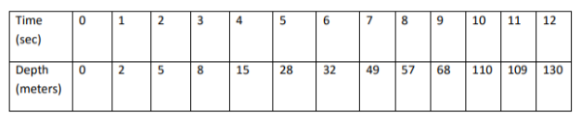

Figure 1: Q03

## Solution

### Velocity Forward

As we know the velocity forward is calculating by using formula

Vf(i)=Depth(i+1) –Depth(i) /∆x

By putting the value, we can get all series.

From 0 to 11 we can calculate like that

Vf(0)=Depth(1) –Depth(0) /∆x

∆x=time (2)-time (1)

∆x =1

V

Vf(0)=2 – 0 /1

=2 m/s

### Acceleration Forward

As we know the acceleration forward is calculating by using formula

Af(i)=velocity (i+1) –Velocity (i) /∆x

By putting the value, we can get all series.

From 0 to 10 we can calculate like that

Af(0)= velocity (1) – velocity (0) /∆x

∆x=time (2)-time (1)

∆x =1

Af(0) = 3-2/1

=1 m/s2

### Velocity Backward

As we know the velocity forward is calculating by using formula

Vb(i)=Depth(i) –Depth(i-1) /∆x

By putting the value, we can get all series.

From 1 to 12 we can calculate like that

Vb(1)=Depth(1) –Depth(0) /∆x

∆x=time (2)-time (1)

∆x =1

Vb(1)=2 – 0 /1

=2 m/s

### Acceleration Backward

As we know the acceleration backward is calculating by using formula

Ab(i)=velocity (i) –Velocity (i-1) /∆x

By putting the value, we can get all series.

From 2 to 12 we can calculate like that

Ab(2)= velocity (2) – velocity (1) /∆x

∆x=time (2)-time (1)

∆x =1

Ab(2) = 3-2/1

=1 m/s2

### Velocity Central

As we know the velocity central difference is calculating by using formula

Vc(i)=Depth(i+1) –Depth(i-1) /2∆x

By putting the value, we can get all series.

From 1 to 11 we can calculate like that

Vc(1)=Depth(2) –Depth(0) /2∆x

∆x=time (2)-time (1)

∆x =1

Vc(1)=5– 0 /2

=2.5 m/s

### Acceleration Central

As we know the acceleration central difference is calculating by using formula

Ac(i)=velocity (i+1) –Velocity (i-1) /2∆x

By putting the value, we can get all series.

From 2 to 10 we can calculate like that

Ac(2)= velocity (3) – velocity (1) /2∆x

∆x=time (2)-time (1)

∆x =1

Ac(2) = 5-2.5/2

=1.25 m/s2

|  |  |  |  |  |  |  |  |
| --- | --- | --- | --- | --- | --- | --- | --- |
| Time (s) | Depth (m) | Forward difference | | Backward difference | | Central difference | |
| Velocity  (m/s) | Acceleration  (m/s^2) | Velocity  (m/s) | Acceleration (m/s^2) | Velocity  (m/s) | Acceleration (m/s^2) |
| 0 | 0 | 2 | 1 | NA | NA | NA | NA |
| 1 | 2 | 3 | 0 | 2 | NA | 2.5 | NA |
| 2 | 5 | 3 | 4 | 3 | 1 | 3 | 1.25 |
| 3 | 8 | 7 | 6 | 3 | 0 | 5 | 3.5 |
| 4 | 15 | 13 | -9 | 7 | 4 | 10 | 1.75 |
| 5 | 28 | 4 | 13 | 13 | 6 | 8.5 | 0.25 |
| 6 | 32 | 17 | -9 | 4 | -9 | 10.5 | 2 |
| 7 | 49 | 8 | 3 | 17 | 13 | 12.5 | -0.5 |
| 8 | 57 | 11 | 31 | 8 | -9 | 9.5 | 7 |
| 9 | 68 | 42 | -43 | 11 | 3 | 26.5 | 5.5 |
| 10 | 110 | -1 | 22 | 42 | 31 | 20.5 | -8.25 |
| 11 | 109 | 21 | NA | -1 | -43 | 10 | NA |
| 12 | 130 | NA | NA | 21 | 22 | NA | NA |

Table 1: Q03 Output

# Question 04

My ID =664

Top oil equation is



Figure 2: Top oil

Bottom oil equation is



Figure 3: bottom oil

For the interaction point we take both equations are equal.

-3.8(x-664)2 -8.6(x-664)-500-664 = 3.8(x-664)2 + 8.6(x-664)-800-664

3.8(x2+440896‬-1328x) -8.6x+5710.4-1164=3.8(x2+440896‬-1328x) + 8.6x -5710.4 – 1464

7.6(x2+440896‬-1328x) + 17.2(𝑥 − 664) − 300 = 0

7.6𝑥2 − 10075.6‬ x+ 3339088.8‬ = 0

Solve the quadratic equation and become values

x1 =669.252

x2 =656.485

|  |  |  |  |
| --- | --- | --- | --- |
| Time | x | Top function | Bottom function |
| 0 | 656.4850 | -1314 | -13140 |
| 1 | 657.7617 | -1258.2 | -1369.8 |
| 2 | 659.0384 | -1214.9 | -1413.1 |
| 3 | 660.3151 | -1183.9 | -1444.1 |
| 4 | 661.5918 | -1165.3 | -1462.7 |
| 5 | 662.8685 | -1159.1 | -1468.9 |
| 6 | 664.1452 | -1165.3 | -1462.7 |
| 7 | 665.4219 | -1183.9 | -1444.1 |
| 8 | 666.6986 | -1214.9 | -1413.1 |
| 9 | 667.9753 | -1258.2 | -1369.8 |
| 10 | 669.2520 | -1314 | -13140 |

Table 2: value of function

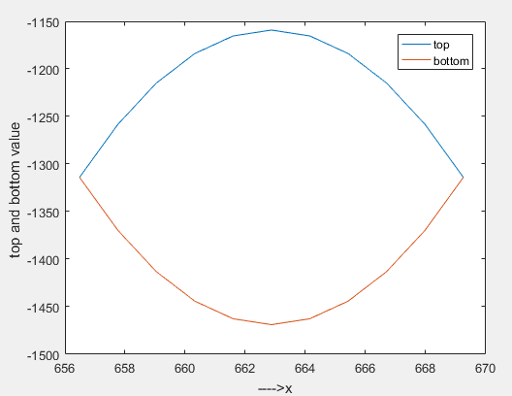

Figure 4: area cross section

## Trapezoidal

𝐴𝑇𝑜𝑝 =ℎ/2[𝑓(𝑥𝑜) + 2 ∗ {𝑓(𝑥1) + 𝑓(𝑥2) + ⋯………𝑓(𝑥9)} + 𝑓(𝑥10)]

𝐴𝐵𝑜𝑡𝑡𝑜𝑚 =ℎ/2[𝑔(𝑥𝑜) + 2 ∗ {𝑔(𝑥1) + 𝑔(𝑥2) + ⋯………𝑔(𝑥9)} + 𝑔(𝑥10)]

|  |  |  |  |
| --- | --- | --- | --- |
| Trapezoidal | Top Area | Bottom area | Net Area |
| -15471 | -18081 | 2610 |

Table 3:Trapezoidal

## Simpson 1/3 Rule

𝐴𝑇𝑜𝑝 =ℎ/3[𝑓(𝑥𝑜) + 4∗ {𝑓(𝑥1) + 𝑓(𝑥3) + 𝑓(𝑥5) + 𝑓(𝑥7) + 𝑓(𝑥9)} + 2 ∗ {𝑓(𝑥2) + 𝑓(𝑥4) + 𝑓(𝑥6) + 𝑓(𝑥8)} + 𝑓(𝑥10)]

𝐴𝐵𝑜𝑡𝑡𝑜𝑚 =ℎ/3[𝑔(𝑥𝑜) + 4∗ {𝑔(𝑥1) + 𝑔(𝑥3) + 𝑔(𝑥5) + 𝑔(𝑥7) + 𝑔(𝑥9)} + 2 ∗ {𝑔(𝑥2) + 𝑔(𝑥4) + 𝑔(𝑥6) + 𝑔(𝑥8)} + 𝑔(𝑥10)]

|  |  |  |  |
| --- | --- | --- | --- |
| Simpson | Top Area | Bottom area | Net Area |
| -15458 | -18094 | 2636.4 |

Table 4: Simpson

## Rectangular Method

𝐴𝑇𝑜𝑝 = ℎ[𝑓(𝑥𝑜) + 𝑓(𝑥1) + ⋯……………………𝑓(𝑥9) + 𝑓(𝑥10)]

𝐴𝐵𝑜𝑡𝑡𝑜𝑚 = ℎ[𝑔(𝑥𝑜) + 𝑔(𝑥1) + ⋯……………………+ 𝑔(𝑥9) + 𝑔(𝑥10)]

|  |  |  |  |
| --- | --- | --- | --- |
| Rectangular | Top Area | Bottom area | Net Area |
| -17148 | -19758 | 2610 |

Table 4: Rectangular